IdeationPhase

Brainstorm&IdeaPrioritizationTemplate

|  |  |
| --- | --- |
| Date | 19/09/2022 |
| Team Members | Akash,Ashwin,Deepan,AshkkarSidhik |
| ProjectName | Project– Smartwastemanagementsystem for  metropolitancities |
| MaximumMarks | 4Marks |

**Step-1:TeamGathering,CollaborationandSelecttheProblemStatement**

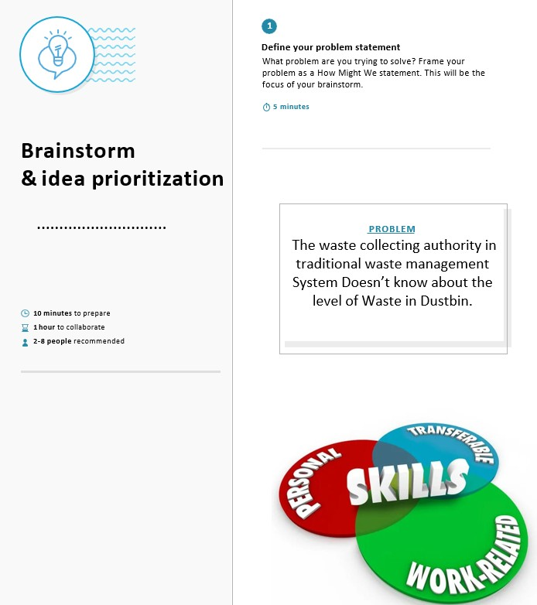

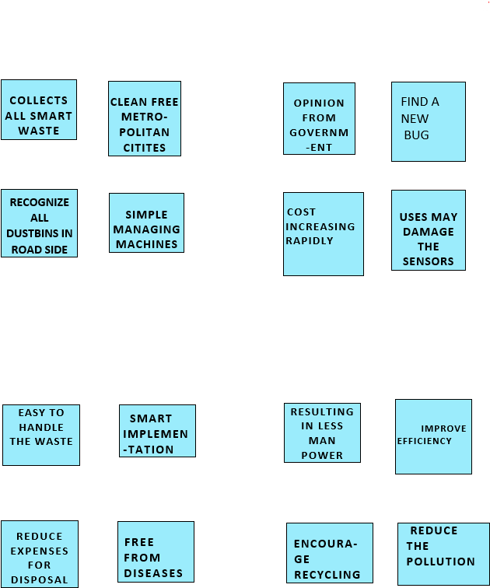

Step-2:Brainstorm,IdeaListingandGrouping

**TEAM MEMBER1**

**ASHWIN G**

**TEAM LEADER**

**ASHKKAR SIDHIK**

**TEAM MEMBER3**

**DEEPAN M**

**TEAM MEMBER2**

**AKASH M**

Step-3:IdeaPrioritization

